HYDROPOWER POTENTIALS AND EFFECTS OF POOR MANUFACTURING INFRASTRUCTURE ON SMALL HYDROPOWER DEVELOPMENT IN SUB-SAHARAN AFRICA

Introduction
The growth of SSA economy has remain sluggish as a consequence of low levels of power supply and infrastructure. This is deterring many wanting to invest across all sectors in the region. The region needs to development large capital projects to grow the economy from the present level to an acceptable level, were it can attract investors. This will require dynamic planning, robust working structures, skills development and reliable funding sources. The power sector in the region faces numerous challenges such as inadequate generation and transmission infrastructure, insufficient fund and unskilled or low numbers of skilled workforce. Other challenges are high cost of executing power projects, epileptic and unreliable supply, poor maintenance of existing facility, poor metering and billing systems, vandalising, and terrorising activities.
“Ban Ki-moon, former UN Secretary-General, stated that energy is the golden thread that connects economic growth, social equity and environmental sustainability” ("Smart Villages (09/03/2017). New Thinking for Off-Grid Communities "). The socio-economic development and all-inclusive growth of the region have been dragged down by unreliable, inadequate and high cost of power generation and distribution. Power and related infrastructure sectors are growth and development facilitators, which SSA must revolutionised in order to pave way for industrialisation and better standard of living. Subsequently, all national governments of SSA consider power sector as one of the priority areas to be developed. Due to its importance in socioeconomic development and all-encompassing growth, power sector development has always attracted international communities’ interventions. Sadly, both domestic and international interventions are yet to achieve the expected results. This study therefore, analyses and examines present power issues in SSA and discusses more enduring ways of increasing and sustaining power (electricity) in the region. Figure 1 shows infrastructural comparison in selected countries, 2015-2016.
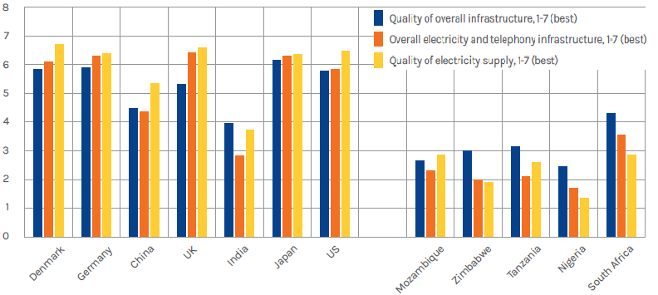
Figure 1: Infrastructural comparison in selected countries, 2015-2016 (JCRA, 2017).

Background study

Present power situation in SSA.
An estimated 17 % (about 1.2 billion people) of the world population have no access to electricity. And about 95 % of this figure are living in the rural areas of developing countries in SSA and Asia (IEA, 2015). The SSA’s power industry track records and statistics are miserable and appalling due to low accessibility, epileptic and poor quality supply. In 2014 factsheet, International Energy Agency (IEA) reported that two-thirds of SSA population, which is about 620 million people has no access to electricity and other modern energy services (IEA, 2014a). And in the region, four out of five people depend on firewood (traditional biomass) for cooking (IEA, 2014b; Nufu-Noma, 2011). The Power sector is typified by gross inadequacies of generation, transmission and distribution infrastructure, poor quality supply, and emission of greenhouse gases (GHG) from fossil plant. About 600 million people in the region have no electricity connection at all. However, South Africa has the highest electrification rate in the region of about 88 %, follow by Nigeria, Cote d’Ivoire, Senegal, Cameroon, Gabon, Ghana, and Botswana of above 50 % each (Anton Eberhard, Katharine Gratwick, Elvira Morella, & Pedro Antmann, 2016). However, South Sudan, Burundi, Malawi, and Sierra Leone are countries in SSA that have the lowest electrification rates (all below 10%) (IEA, 2015).
Rural areas in SSA are the most affected in the power accessibility inadequacy. IEA reported in 2014 that only about less than 2 % of the population in the rural areas have access to electricity (IEA, 2014b). The urbans areas where there are relatively improved rate of supply and high access, but are bedevilled by poor quality supply and frequent power outage. Although, efforts are being made to slow the dismal power picture of SSA, the rapidly growing population of the region shadows these efforts and the improvements made. The total installed capacity (excluding South Africa) of the region is about 80 GW, as shown in Figure 2, and this is equivalent to Republic Korea capacity. Averagely, per capita installed generation capacity across Sub-Saharan Africa is close ^{th} of Latin America’s generation.
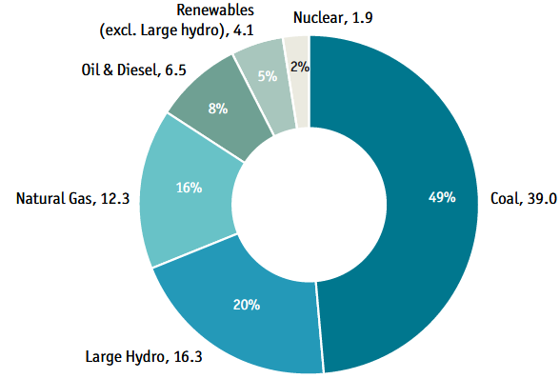

Figure 2. Sub-Saharan Africa’s power generation (GW) (EIU, 2016).
The dismal perennial power generation, coupled with transmission and distribution network facilities inadequacies are the principal causes of low electricity consumption and access. International Energy Agency has declared that SSA region has the poorest power in the world, considering the number of people without access to electricity (IEA, 2014b). The present power situation has defied all the interventions by the governments of the countries in the region and international supports.

Generation and Consumption rates
The average electricity consumption in the region is about 150 KW-hr/capita, which is minute of India or Brazil’s consumption rates. It has been predicted that if this trend continues, about 655 million people in Africa will be without access to electricity (IRENA, 2012a). The stalled capacities of selected countries are shown in Figure 3.
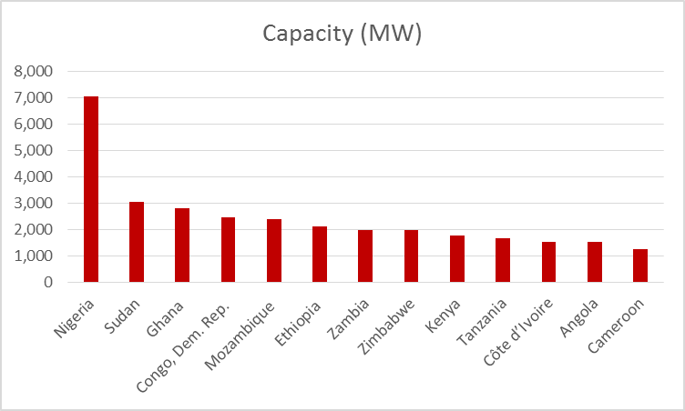
Figure 3: Significant Installed Power Generation Capacity in SSA, 2013 (Anton Eberhard et al., 2016).

Sub-Saharan Africa power requirement
In 2011, IEA predicted that SSA electricity requirement will rise at a compound annual growth rate of 4.6 % and that the present electricity need will be more than 200 % increase by 2030. To adequately address the power challenges in SSA, the annual investment in the power sector was estimated to be $40.8 billion (Anton Eberhard et al., 2016). KPMG reported in 2016 that a quarter of 70 GW power capacity installed in SSA is lost due to poor maintenance and infrastructure. The report added that World Bank has estimated the required power in the region in short term basis to be 70 GW. This will require an annual investment between $120 to $160 billion to provide adequate power to the region by 2030 (De Buys Scott, Christian Lindfeld, Alex Martin, Puleng Pitso, & Mark Engelbrecht, 2016). Over 30 countries in Africa have adopted expensive short-term measures to augment power insufficiency and shortages or face power blackouts. The economic consequence of this occurrence is decline of GDP by more than 2 %.

Renewable energy
The region still derives significant amount of energy from fossil sources such as oil, coal, and gas. Renewable energy can play a substantial role in the region’s energy source due to its abundance- in Kenya and Ethiopia from geothermal power while in the Democratic Republic of Congo to Zambia hydropower. The installed capacity of renewable energy in SSA has increased by 60 % in the last 15 years. However, the region has dropped from 2.7 % to 1.8 % in the global perspective over the same period (IRENA, 2015). In 2016, Economist Intelligence Unit reported the Director of IRENA’s Innovation and Technology Centre, Dolf Gielen, assertion that 40 SSA countries have the last 10 years plan of renewable energy. About 100 GW of renewable projects is said to be in the pipeline in the region, which shows the region’s openness to renewable energy. Africa Union (AU) in conjunction with United Nation (UN) are championing the African Renewable Energy Initiative, which has a goal of 300 GW renewable energy capacity by 2030. IRENA reported that SSA generates power of about 30 GW from renewable energy sources, which is between 25 % ‒ 30 % of the installed capacity. This is dominated by large hydro, accounting for almost 25 % (EIU, 2016).

Global technologies landscape effects on SSA power.
The various interventions to change the present power situation in SSA have not been effective as expected. The interventions are seemed to have been overtaken and consumed by challenges arising from changes in the global technologies landscape, which has given birth to several disruptors in the industry. This has stimulated a shift from landscape of stakeholders and players, traditional generation practices and mixes, methods of operations and systems and funding channels. It has shifted towards the use of new and ground-breaking technologies and dynamics in power infrastructure of SSA. These disruptors that propelled paradigm shift in the industry, have been categorised by Deloitte (Deloitte, 2015) into six classes as presented in Table 1. It is obvious that a fresh and a systematic power infrastructure investment will be required to meet the present and future energy demand in SSA,
Table 1: Trends of power disruption in SSA.
Disruptors | Need trend
African economic growth | Demand generation  Growing commercial & industrial sector  Emerging middle class  Access to electricity
Shifting the energy mix | New capital  Wind, solar, biomass  Gas to power  Nuclear  Coal  Hydro
Changing role of customers | Customer shift  Consumer to producer  Self-generation  Demand managers  Every company is an energy company
Renewable technology | Renewable technology  Affordability of new technologies  Solar PV, storage  Off-grid solutions
Smart grids, smarter utilities | Smart utilities  Smarter utility management  Analytics  Smart grids  Smart metering
Changing market structures and dynamics | Market restructure  Consumer to producer  Self-generation  Demand managers  Every company is an energy company
This notwithstanding, there are some positive improvement in this challenge choked power sector in SSA. This is evidenced in the significant tariff drop of South African Renewable Energy Independent Power Producer Procurement Programme (REIPPPP) due to the competition that exist in the system. Another indication of gradual shift from these challenges is wind and solar PV technologies tariff drop, which is put at 72 % and 46 % drop respectively (Anton Eberhard et al., 2016). Other indicators are Nigerian electricity industry privatisation; massive upgrading, revamping and process optimisation of existing generation and distribution assets in the region; construction of new generation assets, and the shift to energy trilemma. Trilemma is the balancing of the three energy sustainability elements according to the World Energy Council. These elements are energy security, environmental sustainability, and energy equity.
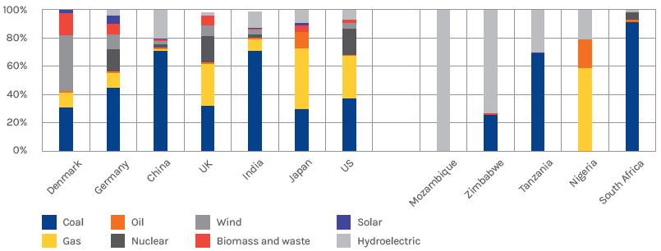
Figure 2: Sources of Power generation in five SSA countries and international comparators, 2014 (JCRA, 2017).
The region still derives significant amount of energy from fossil sources such as oil, coal, and gas. Renewable energy can play a substantial role in the region due to its abundance- in Kenya and Ethiopia from geothermal power while in the Democratic Republic of Congo to Zambia hydropower.

Hydropower
The available hydropower potential in Africa is about 283 GW, and this is more than 300 % of the present electricity consumption in SSA [1]. About 50 % of this potential is located in Central and East Africa (Congo, Cameroon, Ethiopia, DR Congo, and Mozambique). Significant amount is also found in West Africa (Guinea, Nigeria and Senegal) and Southern Africa (Madagascar, Mozambique, South Africa and Angola). Out of the effective 4,000,000 GWh/year hydropower potential available in the region, only 76,000 GWh/year is being generated from a total of 20.3 GW installed capacity as depicted in Figure 4. This is below 10 % of the useful hydro potential available (GSMA, 2014). The proposed Grand Inga project in DC Congo has been described as the largest hydropower project (44 GW) in the region, which will tremendously transform SSA power supply when completed.
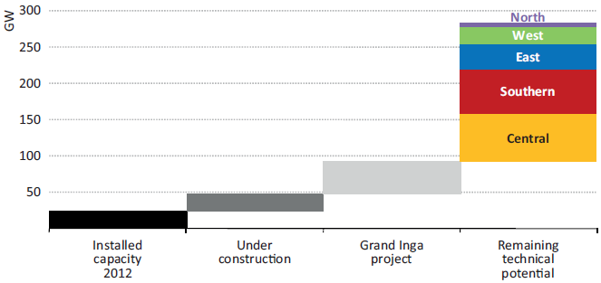
Figure 4: Hydropower potential and installed capacity in Africa (GSMA, 2014).
Harnessing the hydropower potentials in SSA in large scale, will require infrastructure like road to access sites, transport equipment and personnel and for grid transmission. Others requirements include up to date hydrological information about potentials, skilled personnel for design and production of hydro turbine components and systems, and manufacturing infrastructure. In addition, a policy framework is needed for effective regulation, sufficient fund and smart business models. In this study, hydropower will be categorised into small hydropower (SHP), medium hydropower (MHP) and large hydropower (LHP), as shown in Table 2.
Table 2: Broad classification of hydropower (Arun Kumar & Tormod A. Schei, 2009; Energypedia, 2017).
Class | Size
Small hydropower (SHP), MW | SHP<100
Medium hydropower (MHP), MW | 100≤MPH≥500
Large hydropower (LHP), MW | LHP>500
Larger hydropower involves large dams and storage reservoirs and supplies large grids connection. However, there is a decline in the use of large hydropower due to the several challenges that the scheme poses such as:
- Large investment capital.
- Domestic markets maybe too small to consume all the power generated by LHP.
- Water level fluctuation due to seasonal and annual changes.
- LHP dam poses environmental threat such as altering the ecosystem, displacing communities and effects on water availability for other uses.
- Inadequate skilled personnel in hydropower development in some developing countries, etc.

Small hydropower (SHP)
The generation of electrical power capacity of not more than 100 MW from a water source is considered as SHP. However, there is no internationally agreed standard of small hydropower capacity classification as the definition of capacity varies from country to country as shown in Table 3. However, few international organisations such as the International Association for Small Hydro (IASH), the European Small Hydropower Association (ESHA) the United Nations Industrial Development Organization (UNIDO), have generally accepted capacity of up to 10 MW as SHP (Energypedia, 2017).
Small hydropower electrification scheme has been described as most effective for rural and standalone electrification scheme, provided there is availability of SHP potential (Obadote, 2009). This is because the technology is very robust and can last for about 50 years or more with minimal maintenance and is environmentally friendly (P. Oliver, 2002). Other merits are: reduction in network problems; reduction in transmission losses; abundant SHP resources that largely untapped in SSA; cleaner renewable energy (emits low GHG (CO₂)); and it a simple technology that promotes domestic participation. Intergovernmental Panel on Climate Change (IPCC) in 2004, reported that transport and agriculture sectors contributed least to the world’s GHG emissions GHG (13 %), forestry (17 %) while energy production contributed the highest (26 %) (Singal, 2009). The high GHG emission from energy sector is due to the use of fossil fuels for power (SPLASH). Power generation form renewable energy sources, hydropower system produces the lowest cost of electricity, which is between 0.02/kWh and 0.05/kWh USD (IRENA, 2014; UNIDO, 2013).
Table 3: Various size classifications of SHP (Basnayat, 2006; BHA, 2012).
Country | Micro (kW) | Mini (kW) | Small (kW)
United States | < 100 | 100-1000 | 1-30
China | - | < 500 | 0.5-25
USSR | < 100 | - | 0.1-30
France | 5-500 | - | -
India | < 100 | 101-1000 | 1-15
Brazil | < 100 | 100-1000 | 1-30
Norway | < 100 | 100-1000 | 1-10
Nepal | < 100 | 100-1000 | 1-10
Various | < 100 | < 1000 | < 10
Although SHP has been recognised in SSA as a reliable rural and remote areas electrification scheme in the region, the installed capacity is not sufficient. The huge SHP potential in SSA has not been tapped sufficiently, as seen in Figure 5 (Liu, Masera, & Esser, 2013). Many SHP viable sites in the region are yet to be developed due to several limiting factors such as insufficient policy for rural electrification; lack of sufficient fund for SHP; type of Electricity market in the region; lack of strong synergy among the stakeholders; insufficient application of energy research outputs in the region; inadequate human and manufacturing facility development (Williams S. Ebhota & Freddie L. nambao, 2017).
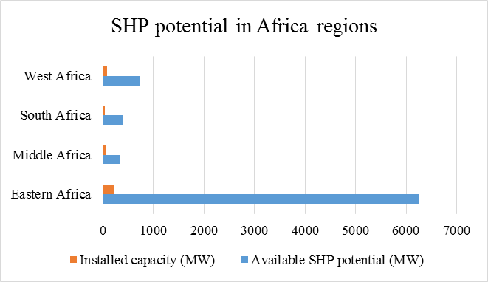
Figure 5: SHP potential in regions of Africa (Liu et al., 2013).
This occurrence is credited to several factors such as finance, technical, political, environmental, policy etc. Electrification of rural areas, and standalone and diversification of energy source favour the use of SHP in SSA. It equally fits into the global pursuit of a cleaner energy to replace or reduce the use of fossil fuels, which are currently the main sources of power generation in the region (Mary Kimani, 2008). Significant use of energy will reduce emission of CO₂ in the region by 27 % (Antonio Castellano, Adam Kendall, Mikhail Nikomarov, & Tarryn Swemmer, 2015). Small hydropower is subdivided into classes based capacity, as presented in Table 4.
Table 4: classification of SHP (Energypedia, 2017).
Category | Capacity | Application
Mini (MH) | < 1 MW | Grid connection
Micro | < 100 kW | Partially grid connection
Pico (PH) | < 10 kW | Island grids
Family (FH) | < ~1 kW | Single households/clusters

Effects of infrastructures on SHP development in SSA

Inadequate domestic manufacturing on SHP development
According to United Nations (UN), the slow pace of economic development of Africa is due to poor infrastructure. Promotion of industrial development in the continent, will stimulate economic growth and poverty reduction. The present manufacturing status of Africa is drastically not proportionate to its population and global manufacturing trend. The level of manufacturing in Africa is only about I % of the world’s manufacturing, while the continent’s population is 15 % of the global population (Chiponda Chimbelu, 2011). Poor manufacturing infrastructure has multiplicity effects on SHP production costs, as the time and cost of transporting facility is increased (economic distance), and heightens project delivering uncertainty. Amongst the infrastructures for economic growth, power and manufacturing infrastructures are intertwined and pose the biggest challenges to the region. To put SSA on economic recovery and development track, power and manufacturing infrastructures need to be revamped simultaneously. Economic growth depends largely on power generation expansion, while sustainability relies on domestic manufacturing.
This study identifies poor designing and manufacturing of SHP components and devices as one the principal barriers against the development of SHP in the region. This factor has been overlooked in the past and even now. The insufficient human and manufacturing infrastructure capacities in SSA, spurs the lingering inadequate power accessibility challenges in the region. The region was ranked the lowest by UNESCO in a study of engineering, manufacturing and construction in undergraduate studies from 2008-2010 (Deloitte, 2015). At present, the economies of most countries in SSA are based on mineral resources while manufacturing plays an insignificant role. The region’s weak manufacturing performance does not provide the needed support for SHP equipment domestic manufacturing participation. Further, there are shortages of the necessary skills and new productive capabilities [28]. The consequence of this is poor and inadequate domestic manufactured SHP components and systems to meet the present region’s power need or for export. Due to these inadequacies, the region depends heavily on foreign SHP equipment products and technologies. Su-Saharan Africa’s gets transport, power equipment and other machinery mostly from Japan, South Korea, Germany, the United Kingdom, China, and the United States as shown in Figure 6.
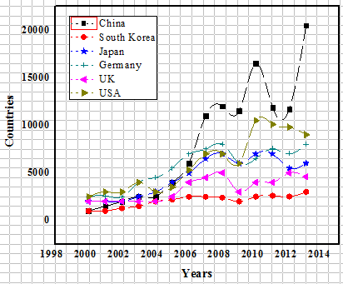
Figure 6: SSA main sources of transport, power and other machineries (Richmond Atta-Ankomah, 2015).

Hydro turbine design and manufacturing procedures
In design process, a correlation exists between manufacturing and material selection processes, shown in Figure 7. To successfully design a product for manufacturing, the design process should harmonise manufacturing facilities and material availability. The poor manufacturing system in SSA has consequence effects on SHP mechanical and electromechanical components and systems. However, if the region’s manufacturing status is integrated with locally sourced materials during SHP design process, good hydro turbine products can come out of the region.
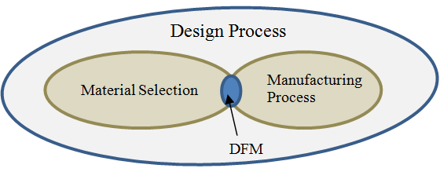 DFM – Design for manufacturing
Figure 7: Correlation between material selection and manufacturing process.

Transportation infrastucture
Across SSA, it is obvious to see dilapidating infrastructures in various sector such as transport, education, manufacturing, communication and power. The roads in the region are poorly maintained and often the roads in rural areas are untiled and this affects transportation of SHP facilities to sites and distribution network. Rail network is limited and less dependable than use of truck in the region. Transportation infrastructural decay, causes increase in the economic distance and often increases production costs, shipping costs and delay in project delivery time.

Domestication of SHP in SSA
Chinese SHP manufacturers are playing vital roles in the growth of SHP in the region. In SHP scheme, cost reduction should not override other local production motivating reasons. Other issues that are vital to be considered are technology adaptation, improve manufacturing, and strengthening of region's human resources in SHP research and development. Although, local manufacture of SHP systems would not solve these issues alone, but would go a long way to make SHP a source of economic strength in the rural areas of SSA. The advantages of domestic production of SHP technology include:

Foreign currency
The local manufacturing of SHP devices and systems will have a significant influence on the sustainability of the domestic market. At present, most countries in SSA depend on imports for energy supply equipment and systems. This means that every locally manufactured and installed SHP component and system will result in a net saving of foreign currency.

SHP projects costs reduction
Domestic manufacturing has the prospective of enlarging the existing markets, in addition, it creates jobs, training, services and financing to decrease SHP projects costs. It will provide opportunities to create parts and adapt SHP technology to meet African specific requirements. Local production of SHP products specifically for SSA markets have potentials of stimulating economic growth of the region. Domestic development of SHP technology could lead to cost reduction and then create a competitive advantage of manufacturing SHP components with locally sourced materials.

Effects of overdependence on foreign power technologies
The power challenges in SSA will persist as long as the region heavily relies on foreign power generation technologies. There are severe consequences of overdependence on foreign power technologies, such as:

Power projects and maintenance
Power projects delivering time, installation, maintenance and repair of SHP facility and downtime are negatively affected by overreliance on foreign power generation and distribution technologies.

Power sustainability
Power sustainability in the region is threatened by overreliance on foreign power technologies. Overdependence on foreign SHP technologies increases project cost, resulting from costs of shipping and hiring of expatriates.

Encourages dependence on international donors
Inadequate power accessibility orchestrated by insufficient local power equipment production promotes dependence on international donors for power projects execution. This is not a reliable way of power sustainability and overcoming the power challenges in the region.

High cost of power project execution
Although, the cost of SHP project varies from country to country in the developing countries, it is higher in SSA countries than Asia countries, as shown in Figure 8. This is due to relatively higher domestic manufacturing of SHP equipment in Asia countries. High cost of shipping of power equipment and hiring of expatriates are responsible for the high cost of power projects in SSA.
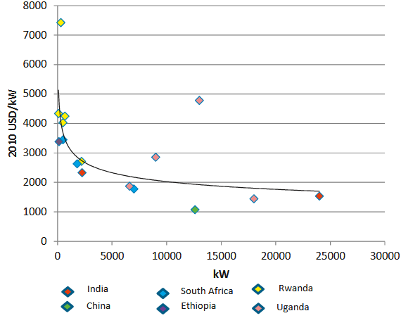
Figure 8: Costs of installed capacity SHP in developing countries (IRENA, 2012b).

Other resultant technical challenges
Other resultant technical challenges due to overreliance on foreign power technology are inadequate skilled personnel for SHP components manufacturing, installation, operation, and maintenance; and readily available parts to replace worn out ones. Skills and manpower development are significant in moving power sector forward. Despite this, university graduates of engineering, construction and manufacturing only account for 4 % compared to other discipline in SSA, as shown in Figure 9.
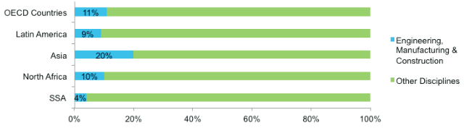
Figure 6: Percentage of SSA university graduates in engineering, construction and manufacturing (2008-2010) (Deloitte, 2015).

Steps to increase power accessibility and sustainability in SSA

Building SHP capacities
Increase in the domestic manufacturing will significantly reduce the cost of SHP projects in the region. Apart from project cost reduction, domestic manufacturing also decreases operational, maintenance and repair costs and downtime. At present in SSA, there is deficit of skills in power industry and supporting sectors that has created technical gap and challenges for local design and development of SHP equipment. Building SHP capacities for both personnel and equipment manufacturing will greatly enhanced chances of increasing power accessibility and sustainability in the region.
Immediate, medium and long terms plans should be used in bridging the human and infrastructure capacities gaps. For rapid response, governments in the region should take the advantage of existing technologies in Asia, Europe and America. Governments in the region should import SHP technologies skills, equipment and systems to expedite skills and technology transfer through reversed engineering and adaptive programmes. For medium and long terms plan, governments in the region should partner with foreign investors to provide the needed technical training to improve the current skills deficit in SSA. The skills should be developed through technical training schools and government should give priority to the study of science and engineering in the region. Funds and other encouragements should be provided to students enrolling for science and engineering in graduate and postgraduate programmes.

Technologies and systems for rural electrification:
As it stands now, according to World Bank, about 66 % of the population of SSA has no access to electricity and they are predominantly in rural areas (World, 2015). In order to make huge impact in electricity accessibility, rural electrification should be given the desired attention and renewable energy technologies (RETs) should be deployed. Large sections of rural areas can be reached out to with SHP technology since the region has huge SHP potentials. This technology is simple and is the cheapest source of renewable energy and is suitable for stand-alone mini-grid or off-grid systems.

New technologies and systems:
The development of SHP in SSA should follow the modern trend in RETs that includes new innovations, such as process automation systems and smart metering. This will open up opportunities for feature relevance and optimisation, which will guarantee sustainability in SSA.

Public-private partnership
In Europe and America, entrepreneurs and innovators are major players in power sector revolution, especially in the development and utilisation renewable energies. Their involvement brought unprecedented trends in both new innovations and disruptions to the sector. As stakeholders in the industry, they take opportunities by identifying power challenges and packaging solutions in form of business models. The business approach has evolved to what is now known as public-private partnership (PPP) in power sector. Active PPP in power sector is a tested and trusted strategy of increasing power supply in Europe and America. Although, PPP approach has been introduced in SSA, it needs to be strengthened. A lot of PPP power projects are required to increase power accessibility in the rural areas of SSA.

Regional power development synergy
Sustainability of adequate and reliable power supply in SSA can be strengthened through the synergy of the countries in the region to build SHP technologies capacity. The capacity building for SHP technology development include foundry, mechatronics, fluid mechanics; computer aided manufacturing (CAM), and material engineering.

Promulgation of renewables and energy supply services decentralisation policies
Governments in the region need to engage in design, planning and policies to get a view of what is really required and to control factor necessary for power industry going forward. The need to share renewables and decentralise energy supply services is significant in boosting energy accessibility in SSA. Policies and regulations that will develop domestic renewable technologies in line with trilemma concept should be promulgated in the region. The world is faced with environmental change and sustainable development challenges. To appropriately respond to these issues, developed countries need to dismantle and change ancient practice, while developing countries can directly apply new technologies and new institutional frameworks. The frame work should allow enterprising industry, and direct energy research and investment focus areas on promotion of domestic based modern renewable energy technologies and innovations. Also, policy based utilities restructuring that will encourage greater PPP in the SSA electricity market, with a focus on renewable energy sources and project funding should be established.

Conclusion
Despite the abundant of huge SHP potentials in SSA, the region’s economic growth is impeded by inadequate, non-reliable and low quality power supply. Globally, SHP scheme has been described as a reliable rural and remote areas electrification scheme. This study sees this scheme as the best electrification option for rural and remote areas. However, the development of the scheme in the region has been effected by the obvious inadequate infrastructure. The most suitable and sustainable electrification scheme for provoking developments and economic activities in the rural and remote areas is SHP. It is regarded as a matured power technology that has low operation and maintenance cost and provides the lowest power generation prices of all off-grid technologies. Small hydropower schemes have been tested globally and certified as a formidable scheme for power production in developing countries. The abundant untapped SHP potential in SSA needs to be converted to a more effective power in the form of electricity. Domestic technology development with facilitate lower cost of power projects, and faster power project delivery and subsequently, rapid energy increment in the region. To develop domestic SHP technology in the region, it will require human and manufacturing infrastructure capacities building, which will increase domestic participation in the design, and manufacturing of SHP components and systems.

Acknowledgement
The authors hereby acknowledge the Research and Postgraduate Support Directorate and the Institute of Systems Science, Durban University of Technology, South Africa.

References
Anton Eberhard, Katharine Gratwick, Elvira Morella, & Pedro Antmann. (2016). Independent Power Projects in Sub-Saharan Africa: Lessons from Five Key Countries (I. B. f. R. a. D. T. W. Bank Ed.). Washington DC: International Bank for Reconstruction and Development.
Antonio Castellano, Adam Kendall, Mikhail Nikomarov, & Tarryn Swemmer. (2015). Brighter Africa: The Growth Potential of the Sub-Saharan Electricity Sector. Retrieved from McKinsey & Company:
Arun Kumar, & Tormod A. Schei. (2009). Special Report Renewable Energy Sources (SRREN): Hydropower. Retrieved from
Basnayat, D. (2006). Background Material: Fundamentals of Small Hydro Power Technologies. Paper presented at the Renewable Energy and Energy Efficiency Partnership, Nairobi, Kenya.
BHA. (2012). British Hydropower Association (BHA). A guide to UK Mini-Hydro Development. Gussage St Michael, Wimborne, UK.
Chiponda Chimbelu. (2011). Poor Infrastructure is Key Obstacle to Development in Africa. Retrieved from http://www.dw.com/en/poor-infrastructure-is-key-obstacle-to-development-in-africa/a-15264436
De Buys Scott, Christian Lindfeld, Alex Martin, Puleng Pitso, & Mark Engelbrecht. (2016). Sub-Saharan Africa Power Outlook: Africa Infrastructure Retrieved from South Africa:
Deloitte. (2015). Sub-Saharan Africa Power Trends: Power Disruption in Africa.
EIU. (2016). The Economist Intelligence Unit. Power Up: Delivering Renewable Energy in Africa. Retrieved from https://www.eiuperspectives.economist.com/sites/default/files/Power%20Up.pdf
Energypedia. (2017). Hydro Power Basics. Retrieved from https://energypedia.info/wiki/Hydro_Power_Basics#cite_note-1
GSMA. (2014). Tower Power Africa: Energy Challenges and Opportunities for the Mobile Industry in Africa. GSMA Green Power for Mobile Programme.
IEA. (2014a). 2014 FACTSHEET Energy in Sub-Saharan Africa today. Retrieved from World Energy Outlook: http://www.worldenergyoutlook.org/media/weowebsite/africa/Fact_sheet_I_Africa_energy_today.pdf
IEA. (2014b). (International Energy Agency). World Energy Outlook Special Report: A Focus on Energy Prospects in Sub-Saharan Africa. Retrieved from Paris:
IEA. (2015). (International Energy Agency). World Energy Outlook 2015: Energy Access Retrieved from Paris:
IRENA. (2012a). International Renewable Energy Agency (IRENA). Africa’s Renewable Energy Future: The Path to Sustainable Growth. Retrieved from Abu Dhabi:
IRENA. (2012b). Renewable Energy Technologies: Cost Analysis Series. Retrieved from Abu Dhabi:
IRENA. (2014). Renewable Power Generation Costs in 2014. International Renewable Energy Agency (IRENA).
IRENA. (2015). International Renewable Energy Agency (IRENA). Renewable Energy Capacity Statistics Retrieved from Abu Dhabi:
JCRA. (2017). Whitepaper: Renewable Energy in Sub-Saharan Africa. Retrieved from http://www.sapvia.co.za/wp-content/uploads/2017/02/Renewable-energy-in-sub-Saharan-Africa.pdf
Liu, H., Masera, D., & Esser, L. (2013). World Hydropower Development Report 2013. United Nation Industrial Development Organisation (UNIDO) and Intertional Centre on Small Hydropower (ICSHP).
Mary Kimani. (2008). Powering up Africa’s Economies: Regional Initiatives can Help Cover Deficits. Africa Renewal, 8.
Nufu-Noma. (2011). Regonal cooperation in academic capacity building. Paper presented at the NUFU-NOMA Dar Es Salaam.
Obadote, D. J. (2009). Energy Crisis in Nigeria: Technical Issues and Solutions. Paper presented at the Power Sector Prayer Conference, Nigeria.
P. Oliver. (2002). Small Hydro Power: Technology and Current Status. Renewable and Sustainable. Energy Reviews, 6 537-556.
Richmond Atta-Ankomah. (2015). Chinese Technologies and Pro-Poor Industrialisation in Sub-Saharan Africa: The Case of Furniture Manufacturing in Kenya. The European Journal of Development Research, 28(3), 397-413.
Singal, S. (2009). Planning and Implementation of Small Hydropower (SHP) Projects. Hydro Nepal, 5.
Smart Villages (09/03/2017). New Thinking for Off-Grid Communities Retrieved from http://e4sv.org/what-is-a-smart-village/
SPLASH. Guidelines for Micro Hydropower Development. Spatial Plans and Local Arrangement for Small Hydro.
UNIDO. (2013). World Small Hydropower Development Report 2013. United Nations Industrial Development Organization and International Center on Small Hydro Power.
Williams S. Ebhota, & Freddie L. nambao. (2017). Facilitating Greater Energy Access in Rural and Remote Areas of Sub-Saharan Africa: Small hydropower. Energy & Environment, 0958305X16686448. doi:10.1177/0958305X16686448
World, B. (2015). Fact Sheet: The World Bank and Energy in Africa Retrieved from http://go.worldbank.org/8VI6E7MRU0

